Victoria Chang
Margaret T. and Henry C. Bourne, Jr. Chair in Poetry
Director of Poetry@Tech
Campus Location: Skiles, First Floor, Poetry@Tech, Suite 030
LMC Phone Number: 404-894-2730

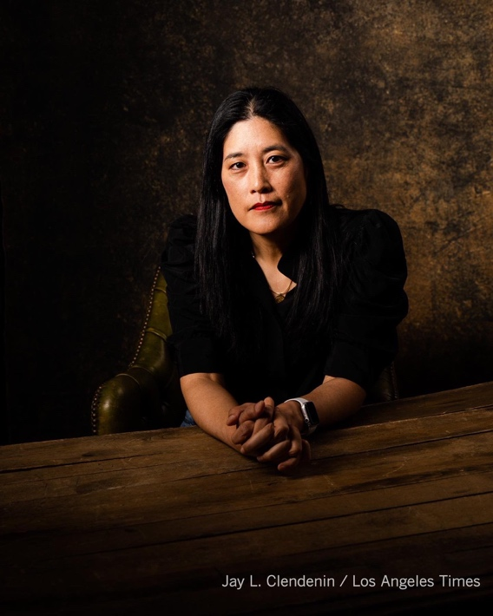

Research Interests
Professor Chang’s research focuses on original poetry, creative nonfiction, fiction, and children’s books. Her work blends genres and often exists at the intersection of identity, family, history, grief, art, and philosophy.

Teaching Interests
Professor Chang’s teaching is focused on poetry reading and writing courses at the undergraduate levels, within the School of Literature, Media, and Communication within the Ivan Allen College School of Liberal Arts. Specific courses include:

LMC 3204 (Poetry and Poetics): A study of traditions of poetic practice and poetic theory in English through intensive line by line readings of poems from different periods in literary history.

LMC 3234 (Creative Writing, Poetry): This course explores a range of creative literary genres, and combines study and analysis of existing modes of one or more forms in order to establish a basis for original creative work by class members.

LMC 4204 (Poetry and Poetics II): Advanced study of the traditions of poetic theory and practice with a special emphasis on processes of poetic conception and revision.

Education
- Warren Wilson College, M.F.A., Holden Fellowship, July 2005
- Stanford University, M.B.A., 1998
- Harvard University, M.A., East Asian Studies, 1993
- University of Michigan, Ann Arbor, B.A. High Honors East Asian Studies, James B. Angell Scholar, 1992

Recent Research and Scholarship
- Tree of Knowledge: Poems, Farrar, Straus & Giroux and Corsair Books (UK), 2026
- Eureka: Middle Grade verse novel, Farrar, Straus & Giroux Children’s Books, 2026
- With My Back to the World: Poems, Farrar, Straus & Giroux and Corsair Books (UK), 2024; Audiobook published by Tantor Audio in the US, narrated by Catherine Ho, and by W.F. Howes in the UK, 2024
- Dear Memory: Letters on Writing, Silence, and Grief: Nonfiction Essays and Visual Art, Milkweed Editions, 2021
- The Trees Witness Everything: Poems, Copper Canyon Press and Corsair Books (UK), 2022
- OBIT: Poems, Copper Canyon Press and Corsair Books (UK), 2020, also translated into numerous languages in multiple countries such as Chile, Argentina, Italy, and China
- Love, Love: Middle Grade verse novel, Union Square Publishing/Hachette Books, 2020
- Barbie Chang: Poems, Copper Canyon Press, 2017

Recent Fellowships, Honors, and Awards
- National Endowment of the Arts Creative Writing Fellowship, 2025
- Civitella Ranieri Writing Fellowship, 2024/2025
- Chowdhury Prize in Literature, 2023
- Guggenheim Fellowship in Poetry, 2017

Recent Book Awards
- With My Back to the World, Forward Prize for the Best Poetry Collection, 2024
- With My Back to the World, Finalist for the PEN/Jean Stein Book Award, 2025
- With My Back to the World, Finalist for the California Book Award, 2025
- With My Back to the World, Finalist for the Kingsley Tufts Book Prize, 2025
- Dear Memory: Letters on Writing, Silence, and Grief, Finalist for the CMLP Firecracker Award in Nonfiction, 2022
- OBIT received the Los Angeles Times Book Prize, 2020
- OBIT received the Anisfield-Wolf Prize, 2020
- OBIT received the PEN Voeckler Award, 2020
- OBIT named a finalist for the National Book Critics Circle Award, 2020
- OBIT shortlisted for the Griffin International Poetry Prize, 2020
- OBIT long listed for a National Book Award, 2020
- OBIT named a finalist for the CMLP Firecracker Book Award, 2020

